Module 4 – Introduction to DBMS

Introduction to SQL

LAB EXERCISES:

Lab 1: Create a new database named school_db and a table called students with the following columns: student_id, student_name, age, class, and address.

Ans. CREATE DATABASE school_db;

USE school_db;

CREATE TABLE students (

student_id INT PRIMARY KEY AUTO_INCREMENT,

student_name VARCHAR(100) NOT NULL,

age INT,

class VARCHAR(50),

address VARCHAR(255)

);

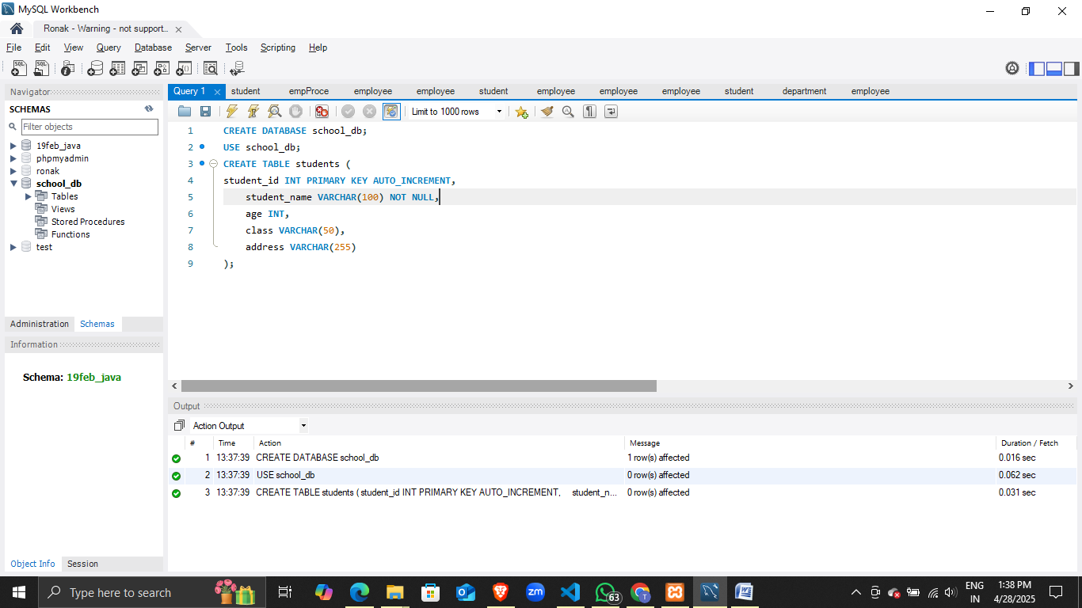

Lab 2: Insert five records into the students table and retrieve all records using the SELECT statement.

Ans. INSERT INTO students (student_name, age, class, address)

VALUES

('Aarav Sharma', 14, '9th Grade', '123 MG Road, Surat'),

('Meera Patel', 15, '10th Grade', '456 LP Avenue, Surat'),

('Rohan Desai', 13, '8th Grade', '789 SK Street, Surat'),

('Ishita Mehta', 14, '9th Grade', '321 VR Lane, Surat'),

('Kunal Joshi', 16, '11th Grade', '654 YZ Road, Surat');

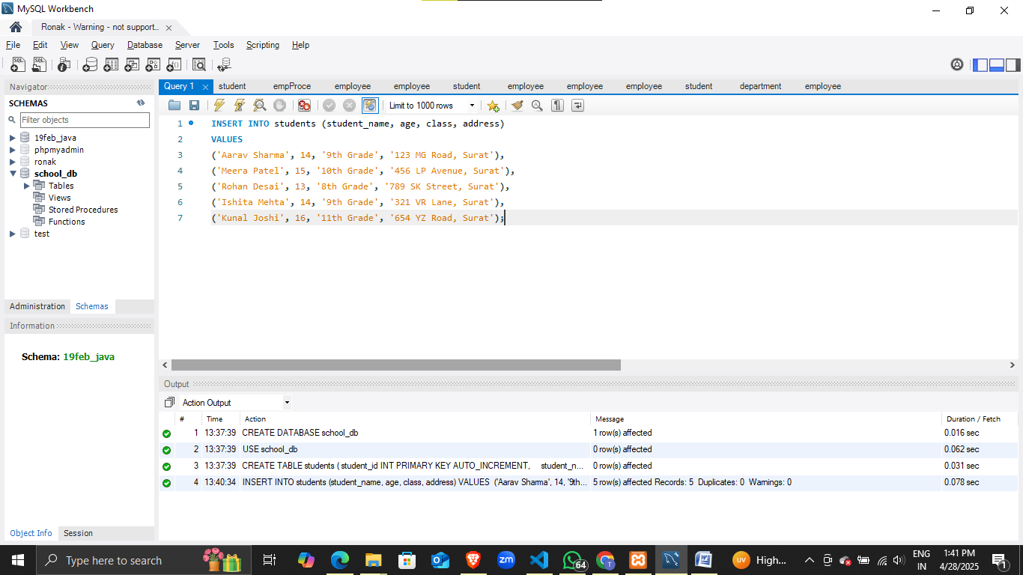

To View

SELECT * FROM students;

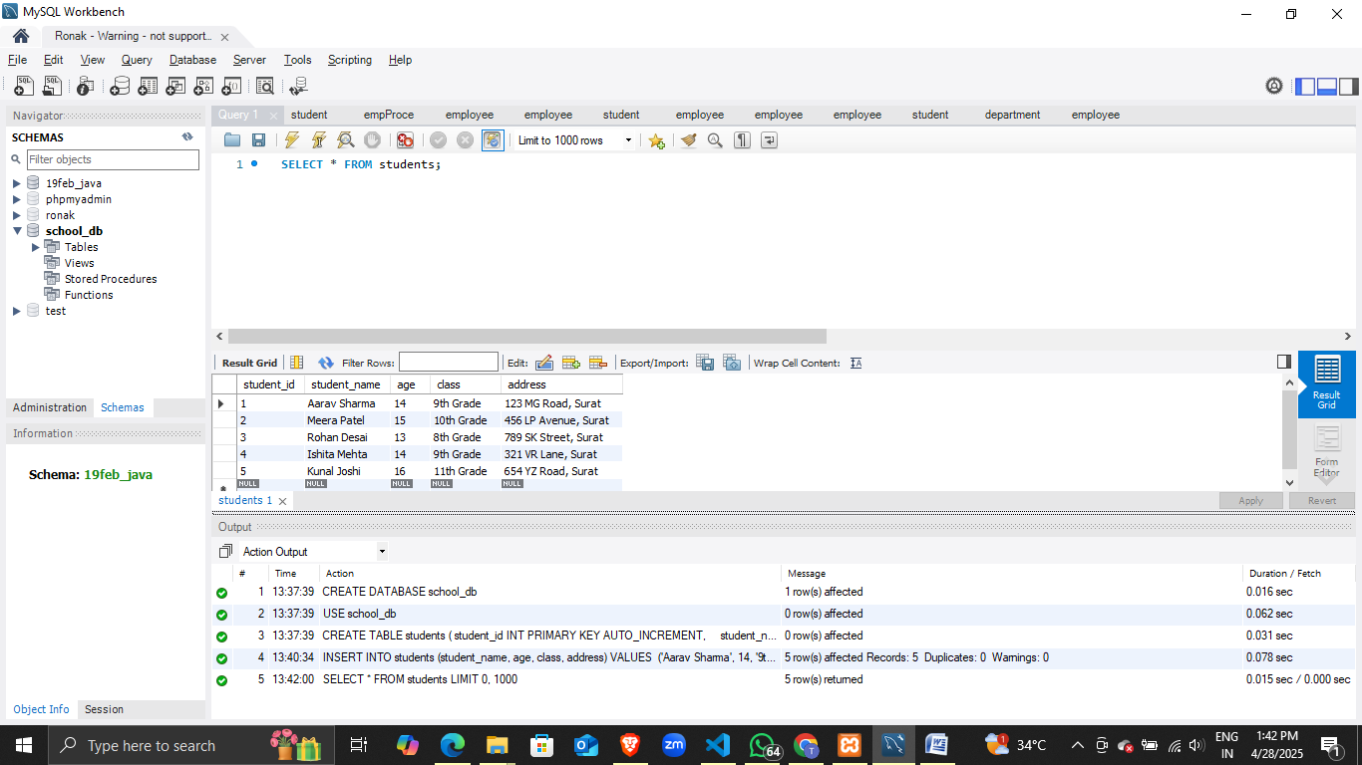

Lab 1: Write SQL queries to retrieve specific columns (student_name and age) from the students table.

Ans. SELECT student_name, age

FROM students;

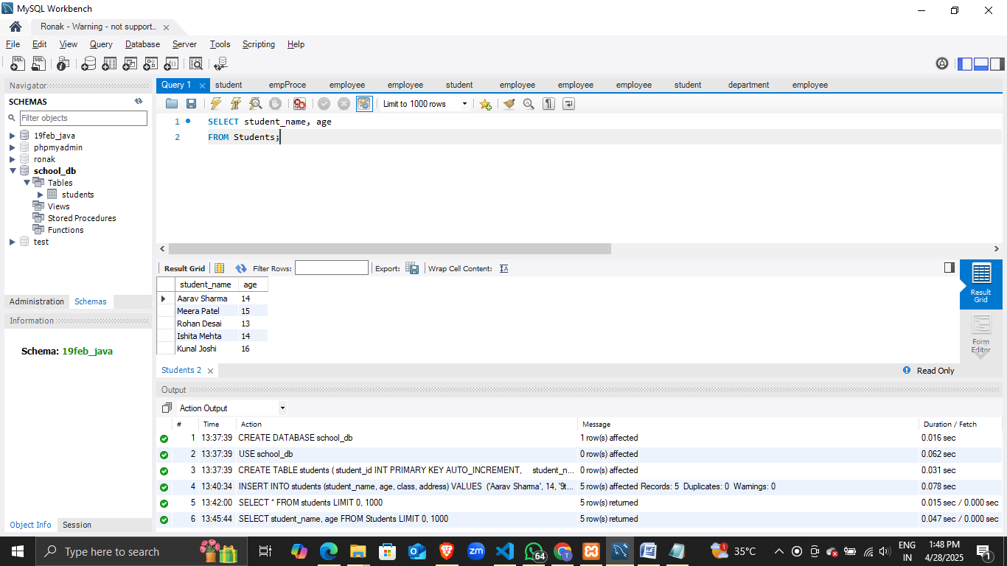

Lab 2: Write SQL queries to retrieve all students whose age is greater than 10?

Ans. SELECT *

FROM students

WHERE age > 10;

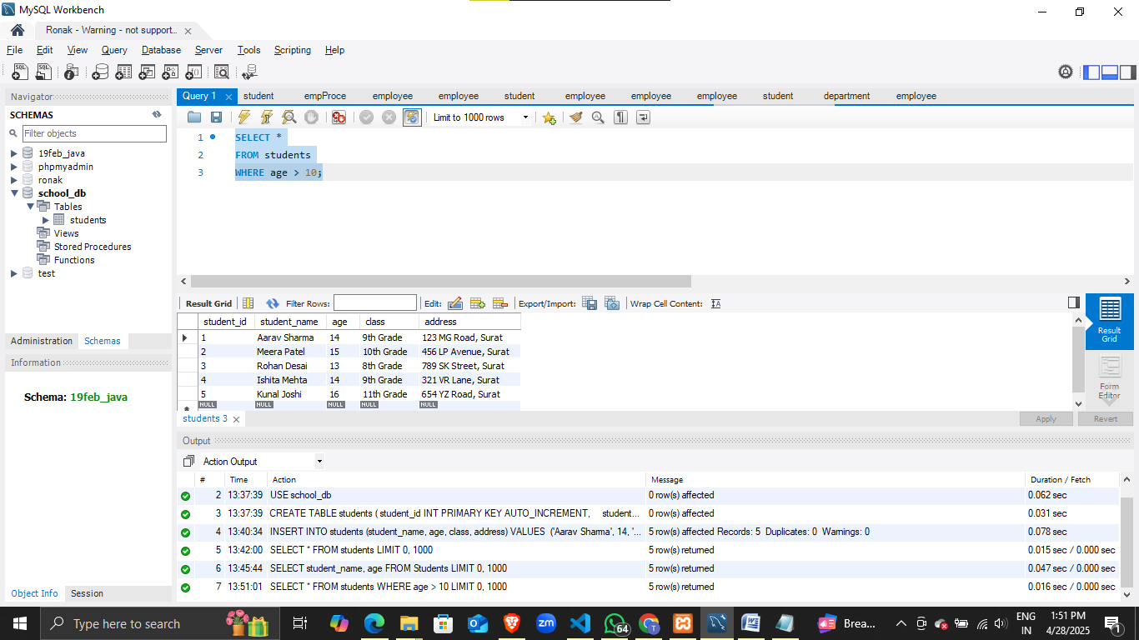

Lab 1: Create a table teachers with the following columns: teacher_id (Primary Key), teacher_name (NOT NULL), subject (NOT NULL), and email (UNIQUE).

Ans. CREATE TABLE teachers (

teacher_id INT PRIMARY KEY AUTO_INCREMENT,

teacher_name VARCHAR(100) NOT NULL,

subject VARCHAR(100) NOT NULL,

email VARCHAR(150) UNIQUE

);

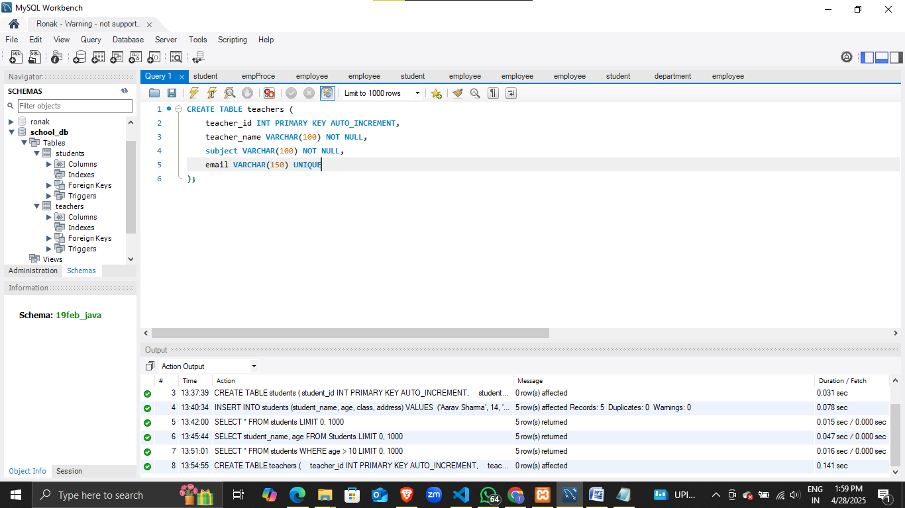

Lab 2: Implement a FOREIGN KEY constraint to relate the teacher_id from the teachers table with the students table.

Ans. ALTER TABLE students

ADD teacher_id INT;

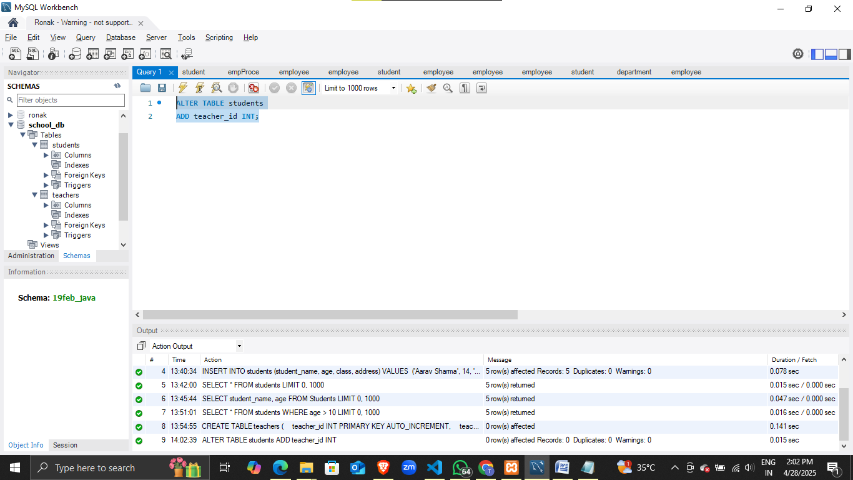

ALTER TABLE students

ADD CONSTRAINT fk_teacher

FOREIGN KEY (teacher_id)

REFERENCES teachers(teacher_id);

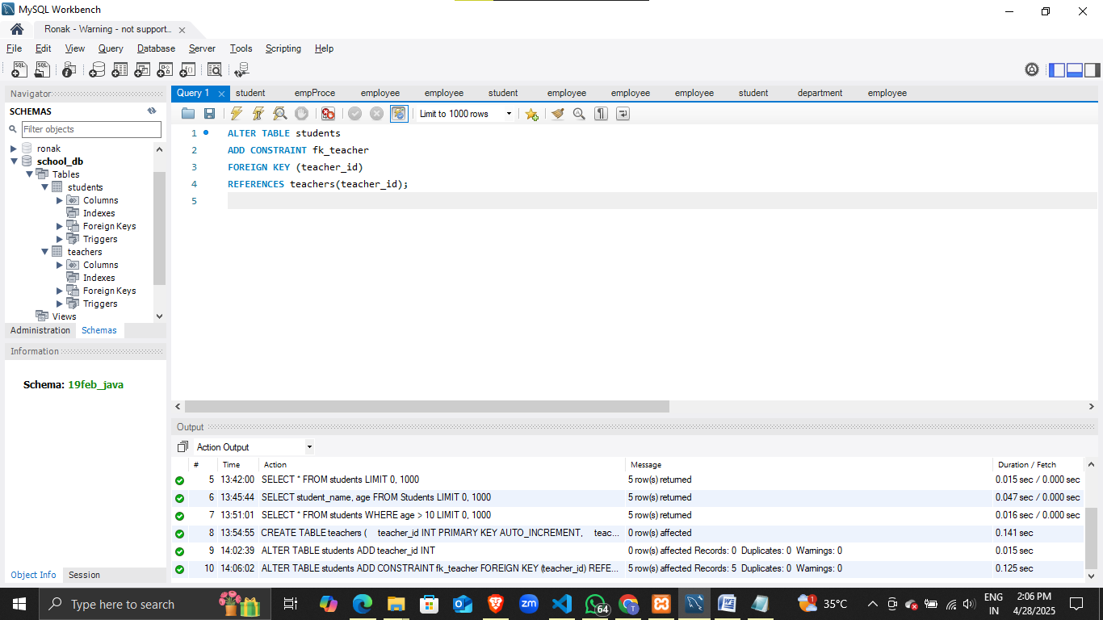

Lab 1: Create a table courses with columns: course_id, course_name, and course_credits. Set the course_id as the primary key.

Ans. CREATE TABLE courses (

course_id INT PRIMARY KEY AUTO_INCREMENT,

course_name VARCHAR(100) NOT NULL,

course_credits INT

);

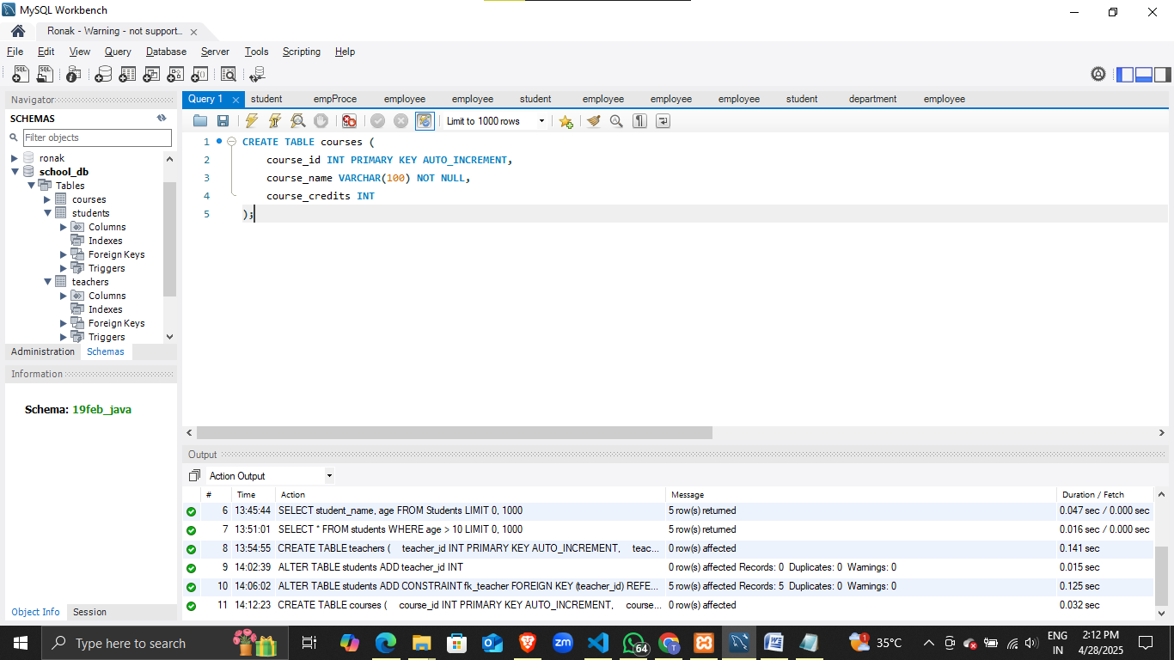

Lab 2: Use the CREATE command to create a database university_db.

Ans. CREATE DATABASE university_db;

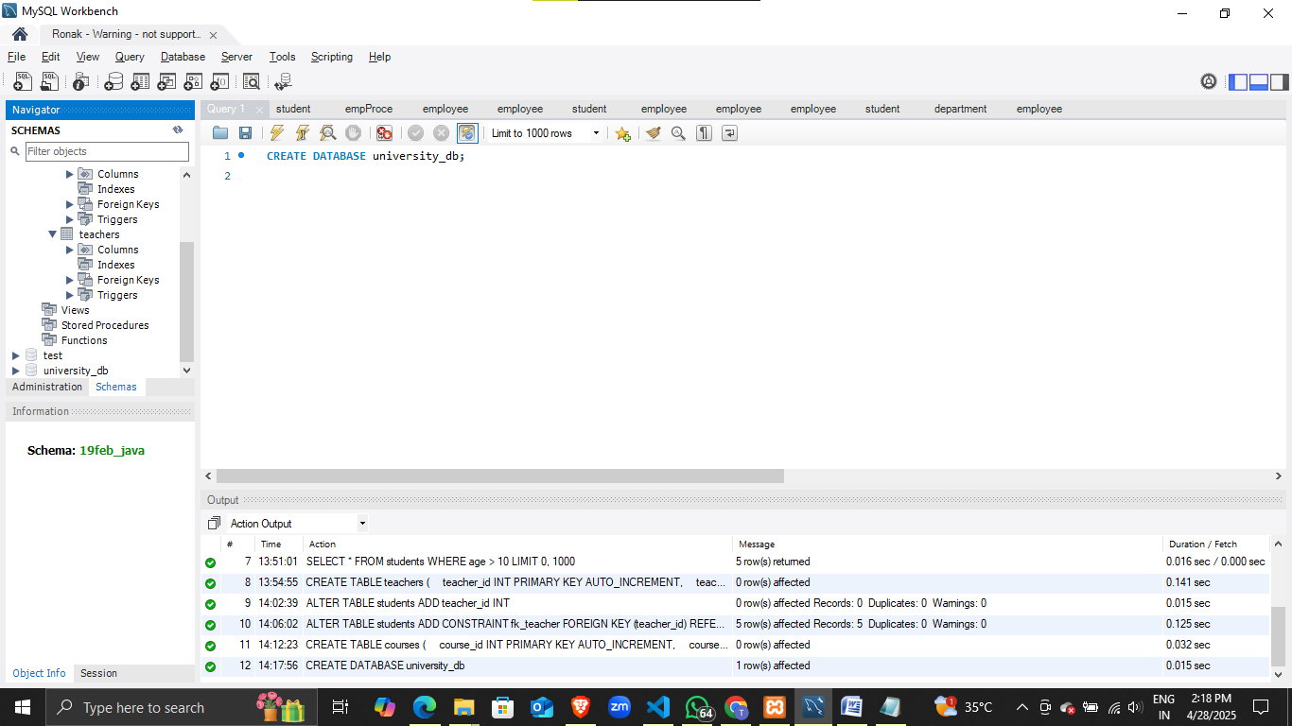

Lab 1: Modify the courses table by adding a column course_duration using the ALTER command.

Ans. ALTER TABLE courses

ADD course_duration VARCHAR(50);

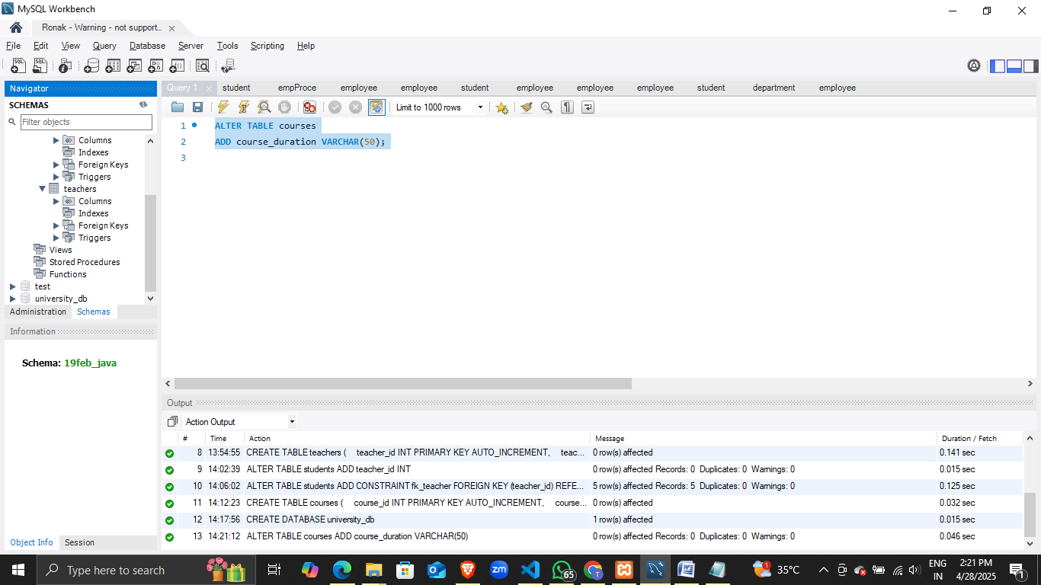

Lab 2: Drop the course_credits column from the courses table.

Ans. ALTER TABLE courses

DROP COLUMN course_credits;

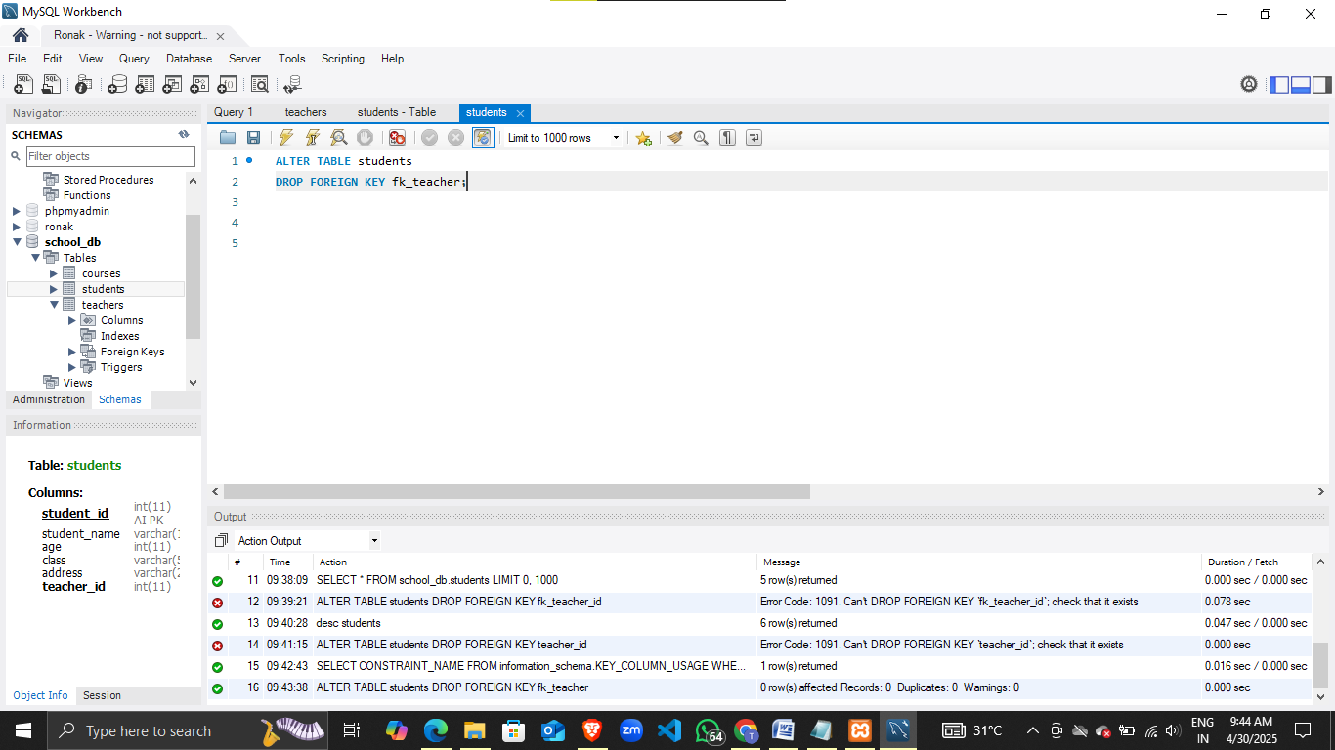

Lab 1: Drop the teachers table from the school_db database.

Ans. ALTER TABLE students

DROP FOREIGN KEY fk_teacher;

DROP TABLE school_db.teachers;

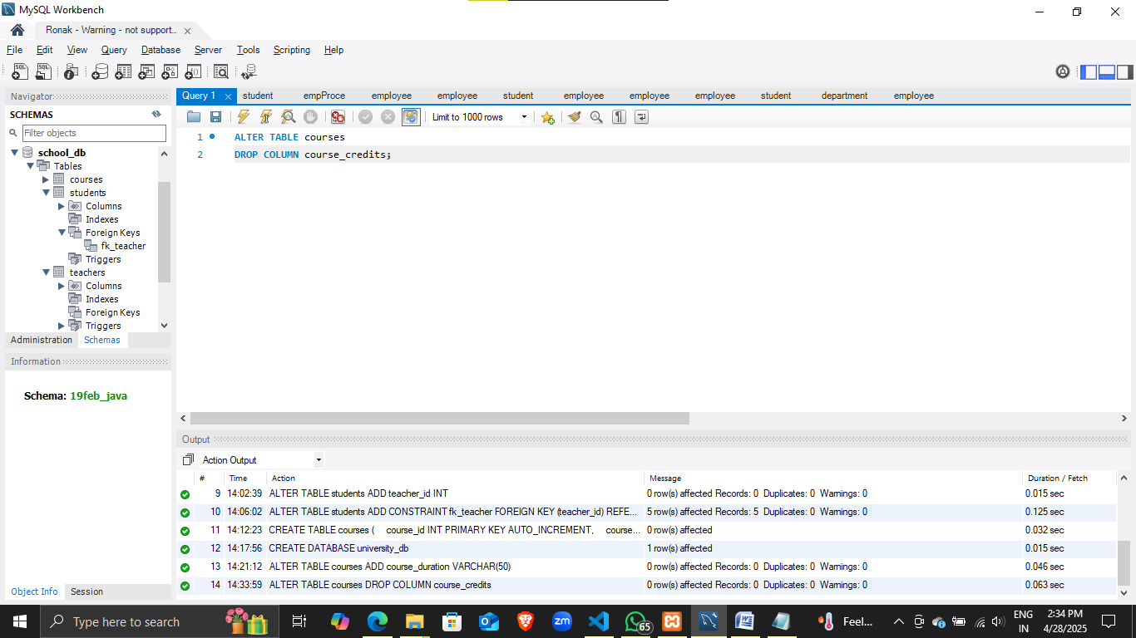

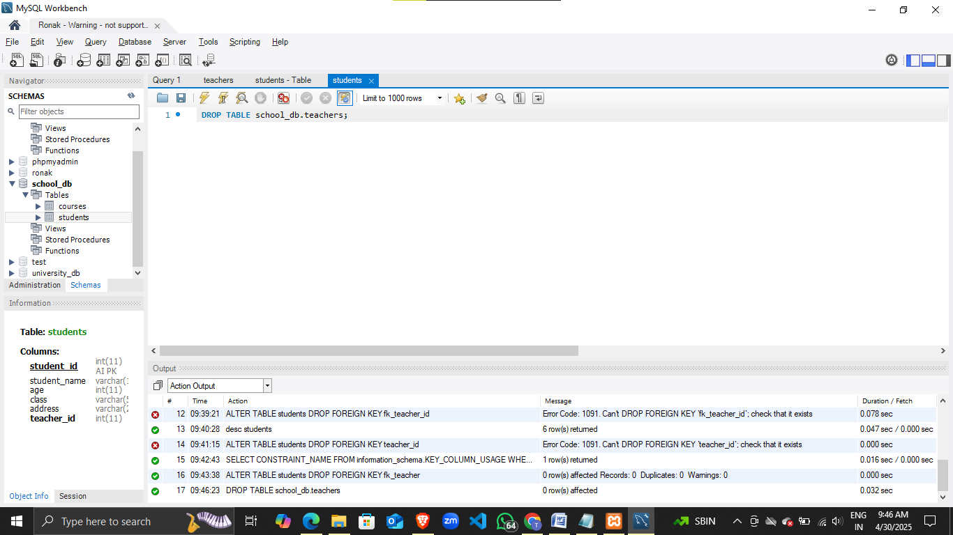

Lab 2: Drop the students table from the school_db database and verify that the table has been removed.

Ans. USE school_db;

DROP TABLE students;

SHOW TABLES LIKE 'students';

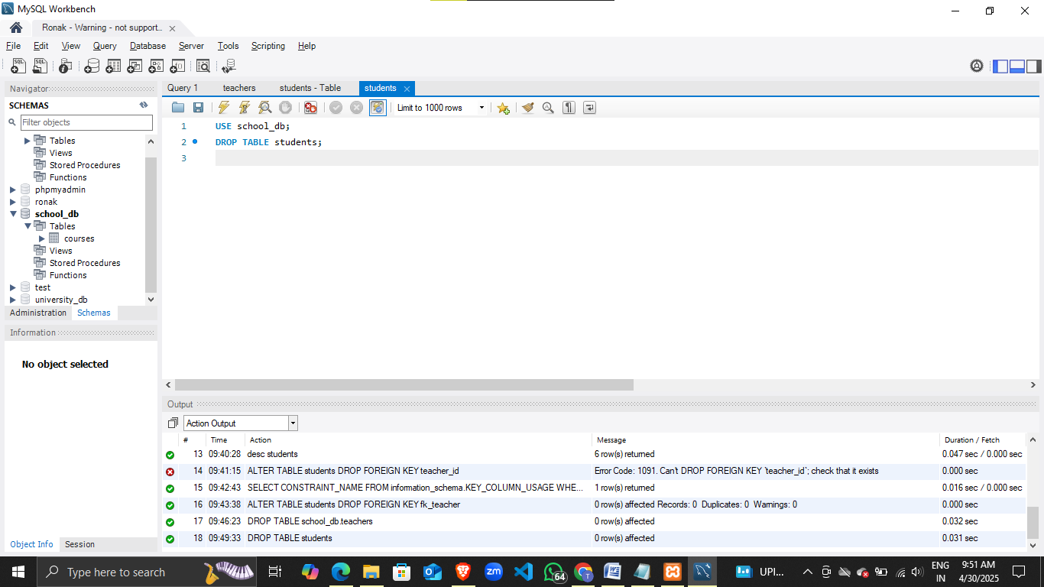

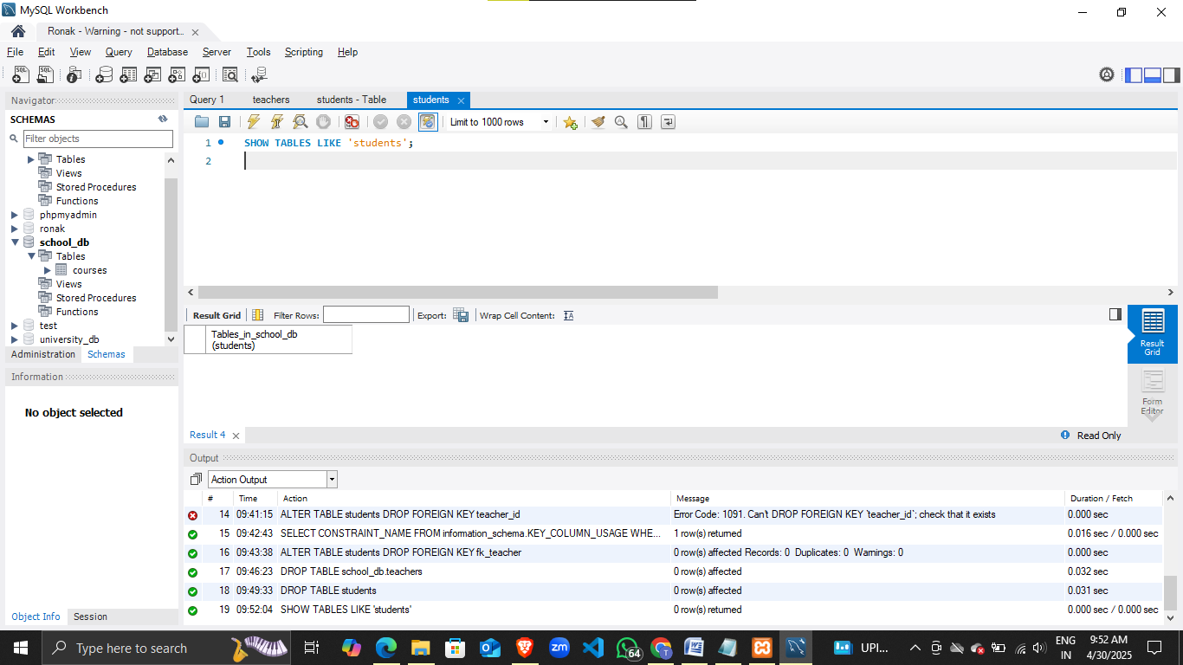

Lab 1: Insert three records into the courses table using the INSERT command.•

Ans. INSERT INTO courses (course_id, course_name, course_duration)

VALUES

(1, 'Mathematics', 3),

(2, 'History', 4),

(3, 'Biology', 3);

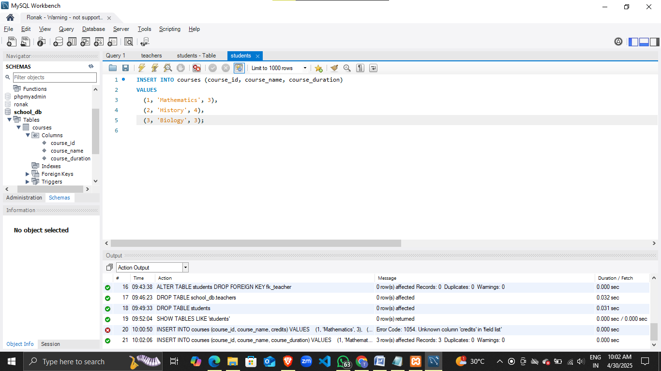

Lab 2: Update the course duration of a specific course using the UPDATE command.

Ans. UPDATE courses

SET course_duration = '6 months'

WHERE course_id = 2;

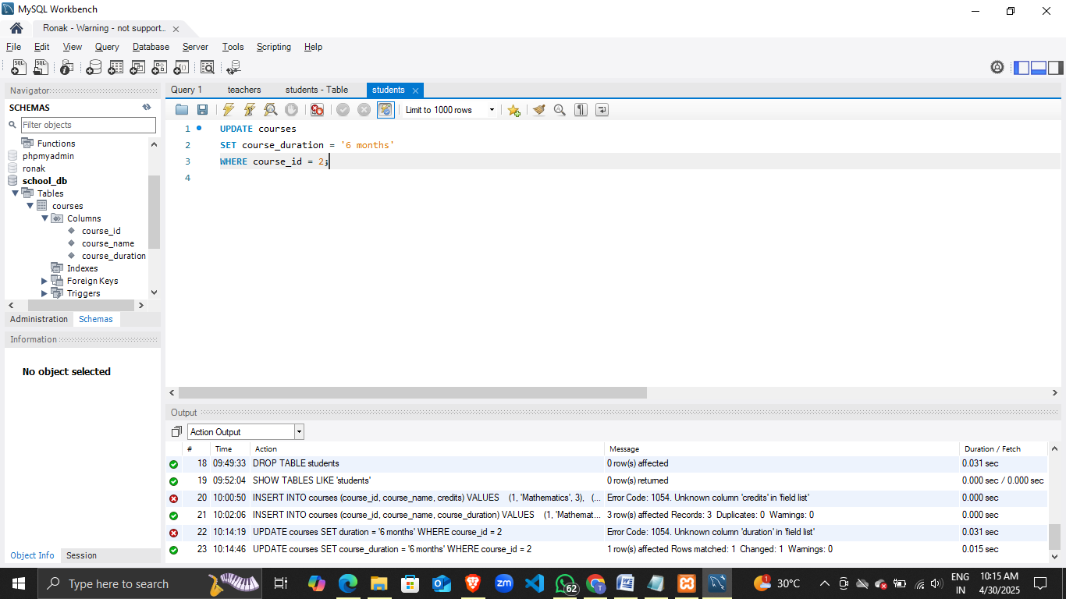

Lab 3: Delete a course with a specific course_id from the courses table using the DELETE command.

Ans. DELETE FROM courses

WHERE course_id = 3;

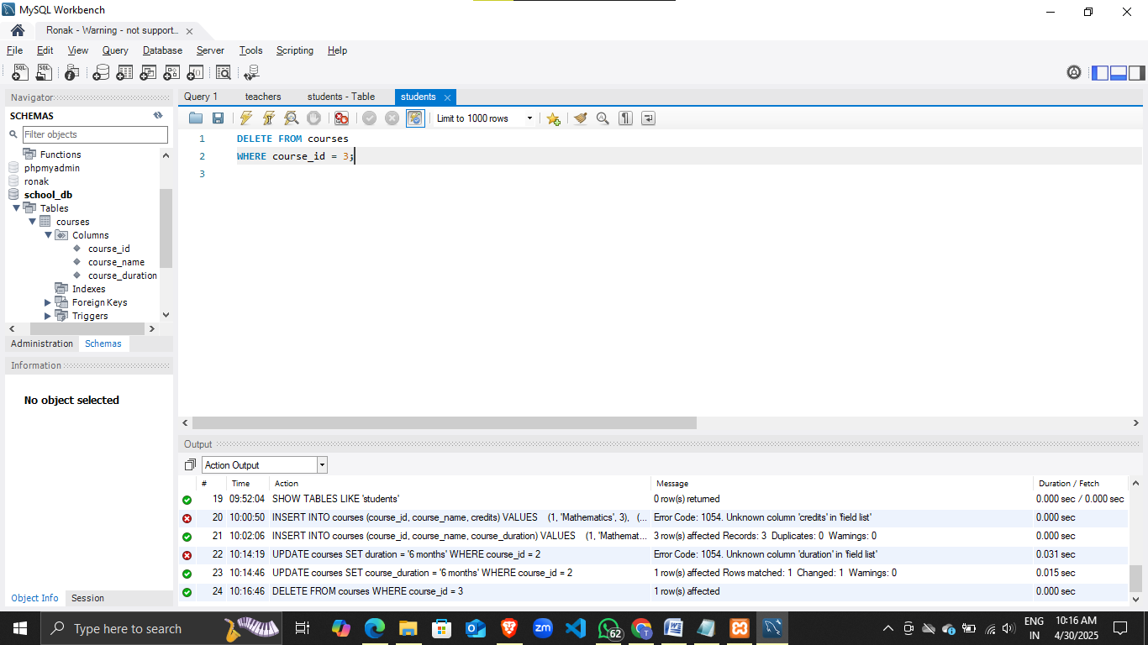

Lab 1: Retrieve all courses from the courses table using the SELECT statement.

Ans. SELECT * FROM courses;

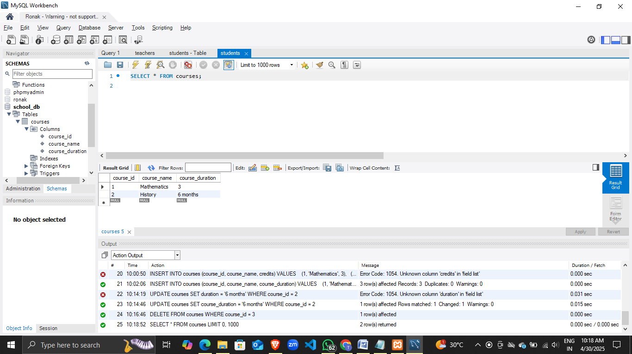

Lab 2: Sort the courses based on course_duration in descending order using ORDER BY.

Ans. SELECT * FROM courses

ORDER BY course_duration DESC;

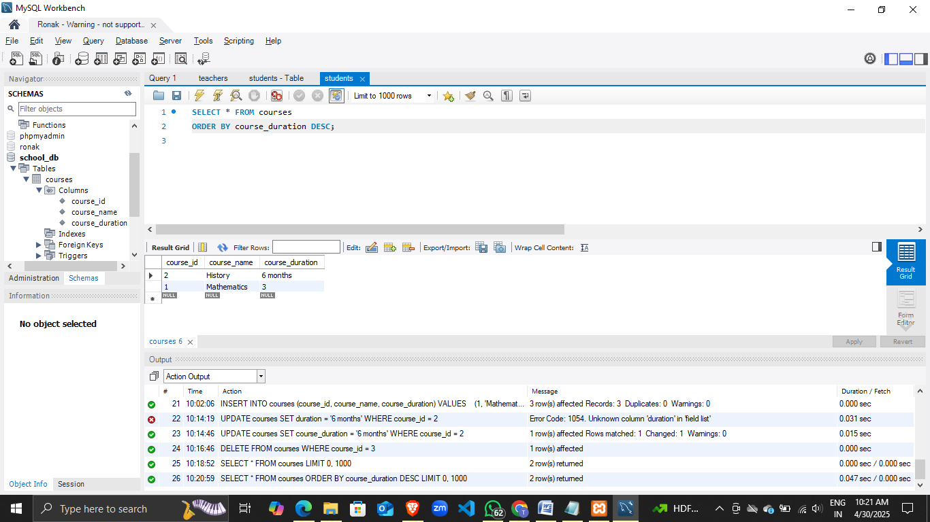

Lab 3: Limit the results of the SELECT query to show only the top two courses using LIMIT.

Ans. SELECT * FROM courses

LIMIT 2;

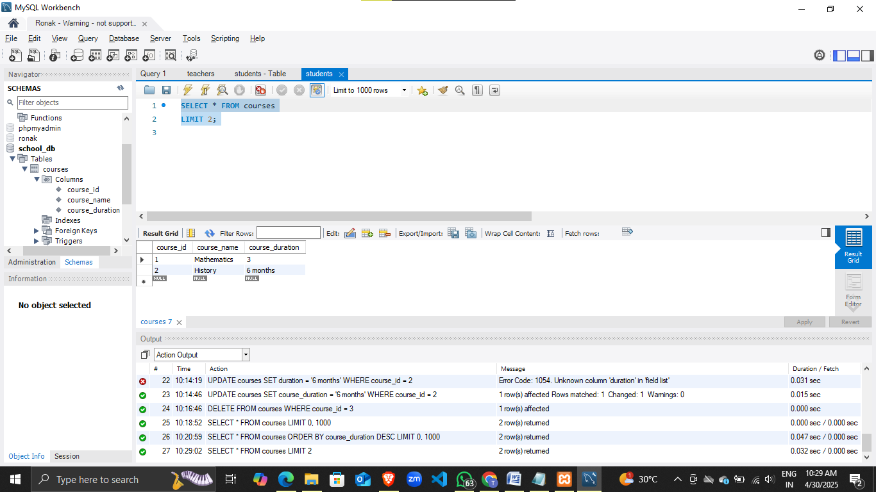

Lab 1: Create two new users user1 and user2 and grant user1 permission to SELECT from the courses table.

Ans. CREATE USER 'user1'@'localhost' IDENTIFIED BY 'password1';

CREATE USER 'user2'@'localhost' IDENTIFIED BY 'password2';

GRANT SELECT ON school_db.courses TO 'user1'@'localhost';

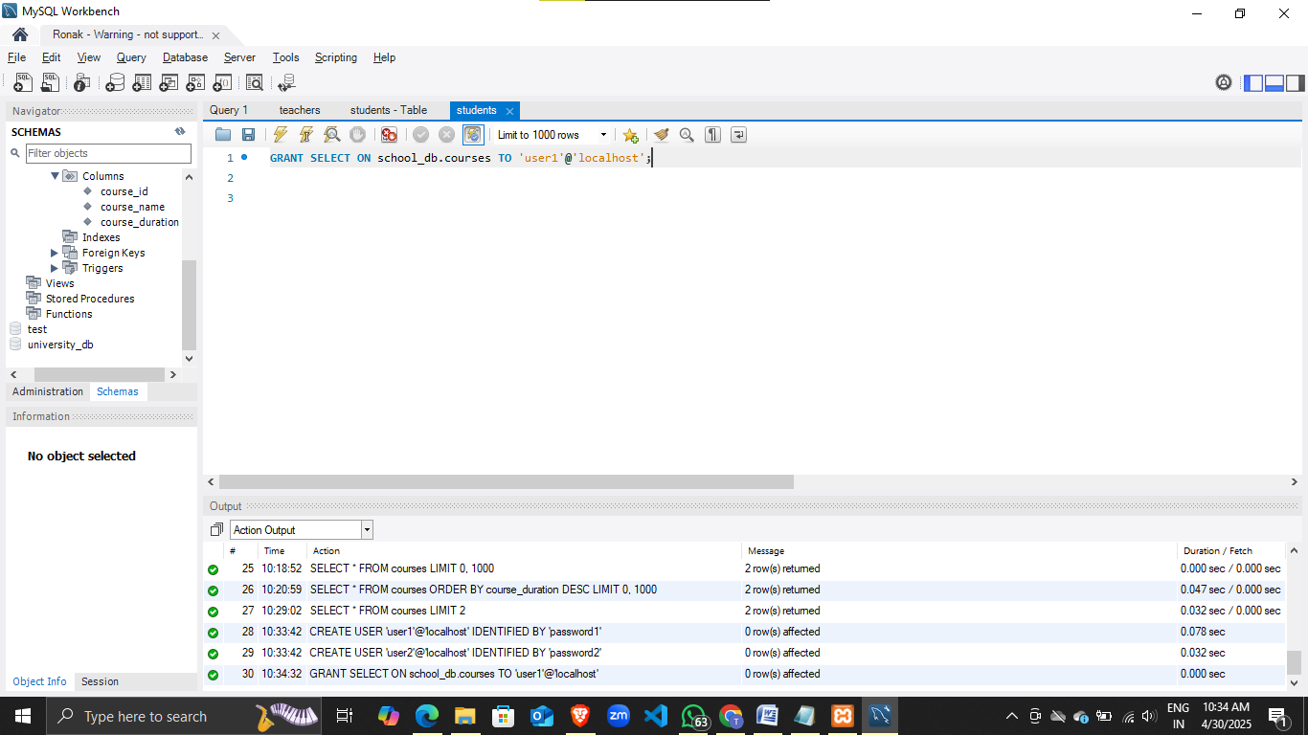

Lab 2: Revoke the INSERT permission from user1 and give it to user2.

Ans. REVOKE INSERT ON school_db.courses FROM 'user1'@'localhost';

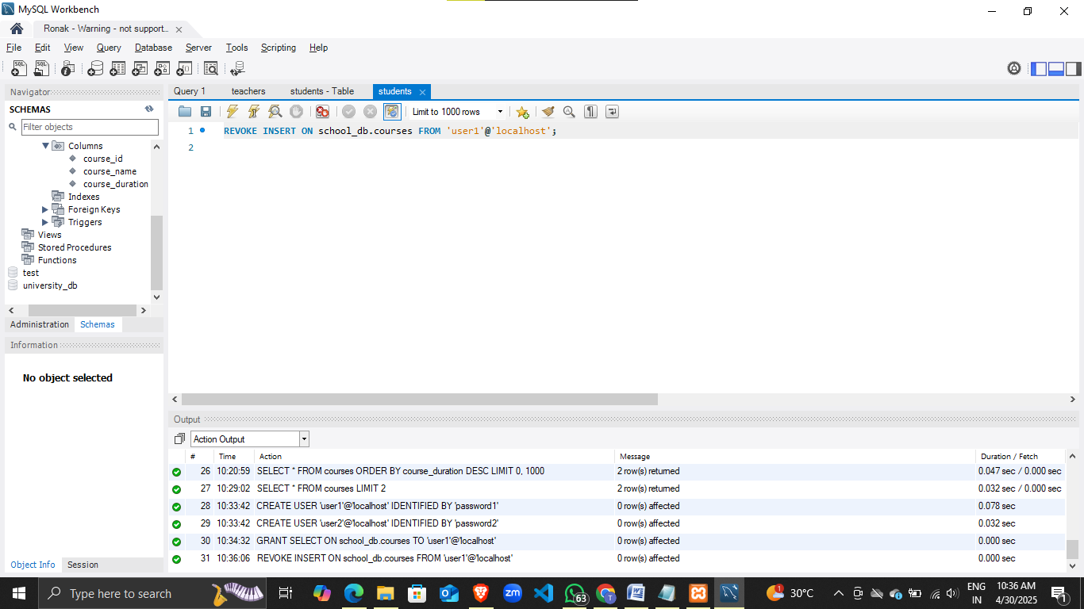

GRANT INSERT ON school_db.courses TO 'user2'@'localhost';

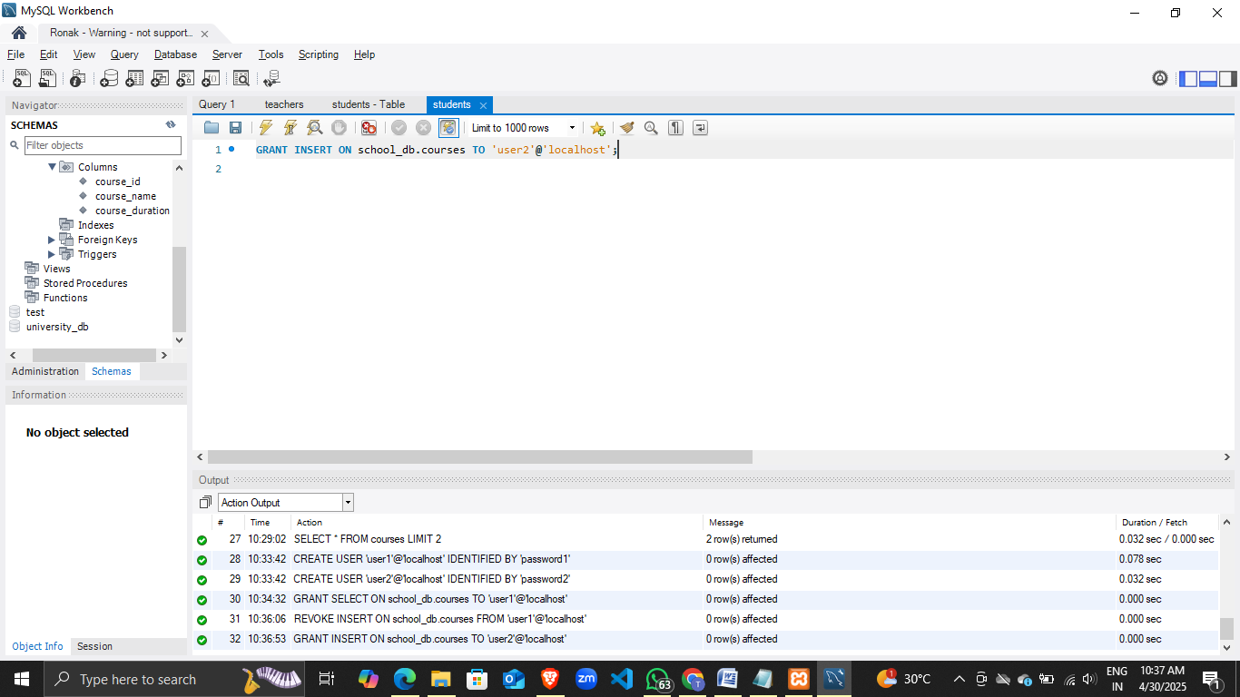

Lab 1: Insert a few rows into the courses table and use COMMIT to save the changes.

Ans. START TRANSACTION;

INSERT INTO courses (course_id, course_name, course_duration)

VALUES

(4, 'Physics', '6 months'),

(5, 'Chemistry', '5 months'),

(6, 'English', '4 months');

COMMIT;

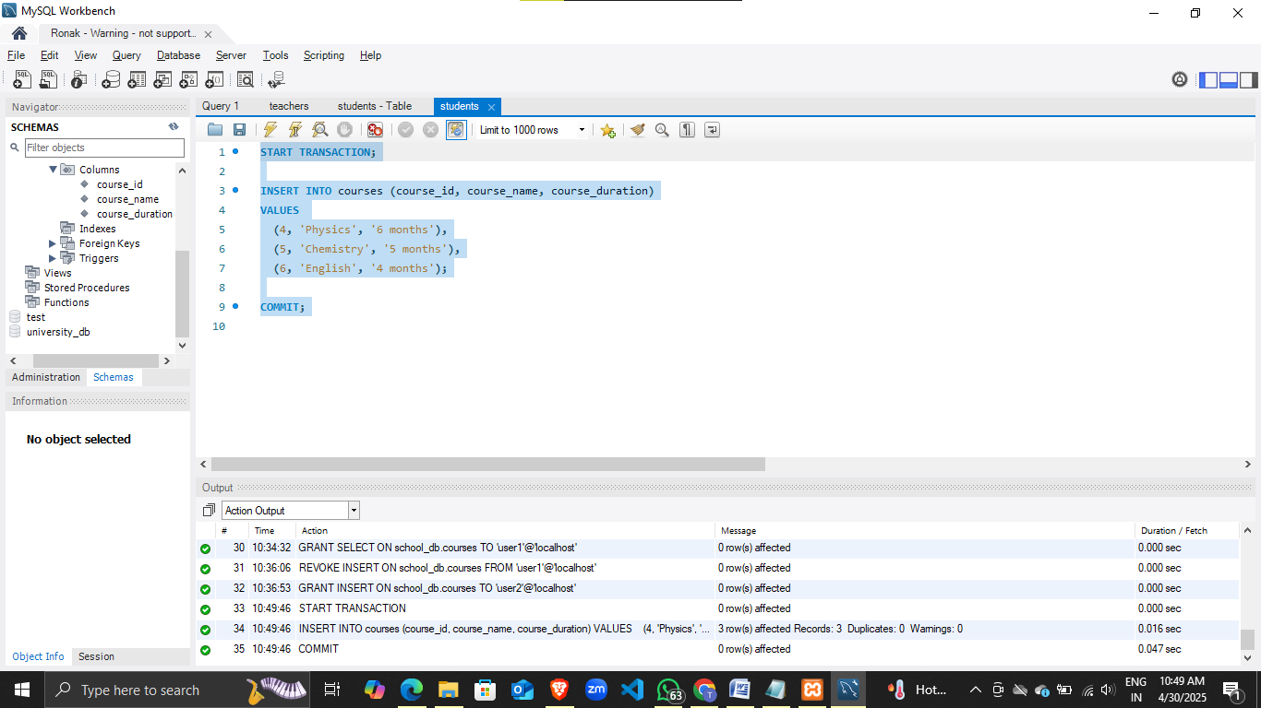

Lab 2: Insert additional rows, then use ROLLBACK to undo the last insert operation.

Ans. START TRANSACTION;

INSERT INTO courses (course_id, course_name, course_duration)

VALUES

(7, 'Computer Science', '8 months'),

(8, 'Economics', '6 months');

ROLLBACK;

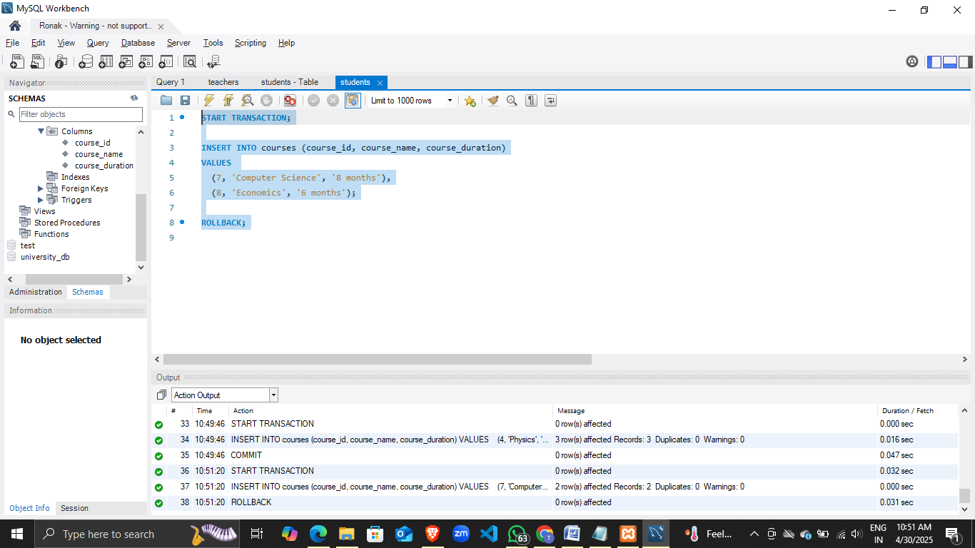

Lab 3: Create a SAVEPOINT before updating the courses table, and use it to roll back specific changes.

Ans. START TRANSACTION;

SAVEPOINT before_update;

UPDATE courses

SET course_duration = '10 months'

WHERE course_id = 4;

ROLLBACK TO SAVEPOINT before_update;

COMMIT;

